**Trabajo Práctico 5 - Sistemas Operativos**

**Integrantes:**

* Borgogno, Francisco
* Cañas, Felipe
* Lucero Ruiz, Maximo
* Quesada, Santiago

**Profesor:** Funes, Gustavo

**1.**

| find . -type f | head -n 10 |
| --- |

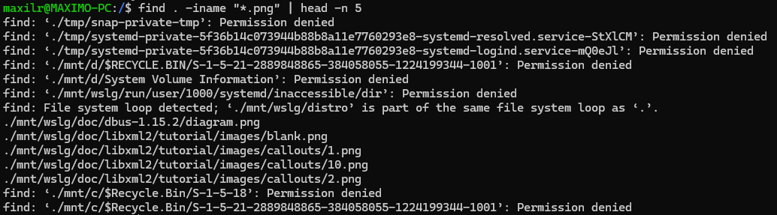

**2.**

| **cp /mnt/wslg/doc/dbus-1.15.2/diagram.png /mnt/wslg/doc/libxml2/tutorial/images/blank.png /mnt/wslg/doc/libxml2/tutorial/images/callouts/1.png /mnt/wslg/doc/libxml2/tutorial/images/callouts/10.png /mnt/wslg/doc/libxml2/tutorial/images/callouts/2.png tu_user/Universidad/2do/Mat-21/** |
| --- |



**3.**

| **find / -iname "*.txt" | head -n 5** |
| --- |

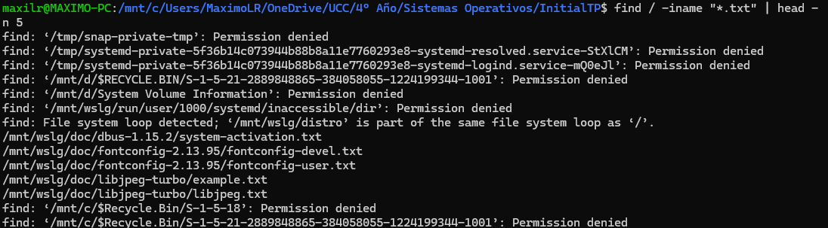

**4.**

| **cp /mnt/wslg/doc/dbus-1.15.2/system-activation.txt /mnt/wslg/doc/fontconfig-2.13.95/fontconfig-devel.txt /mnt/wslg/doc/fontconfig-2.13.95/fontconfig-user.txt /mnt/wslg/doc/libjpeg-turbo/example.txt /mnt/wslg/doc/libjpeg-turbo/libjpeg.txt tu_user/Universidad/2do/Mat-22/** |
| --- |



**5.**

| **ls -lSr tu_user/Universidad/2do/Mat-22/** |
| --- |

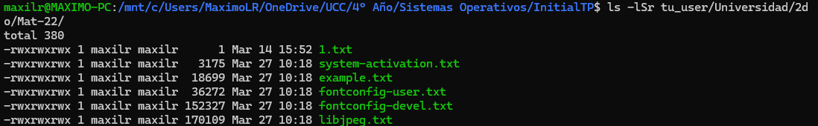

| **ls -lSr tu_user/Universidad/2do/Mat-22/ | head -n 3** |
| --- |



| **rm <FILENAME>** |
| --- |

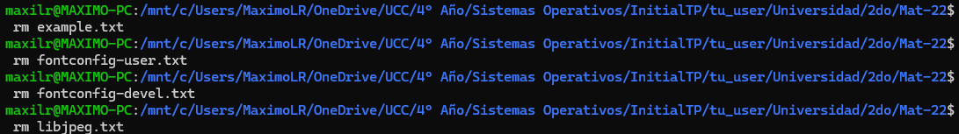

**6.**

| **diff -y 1.txt system-activation.txt** |
| --- |

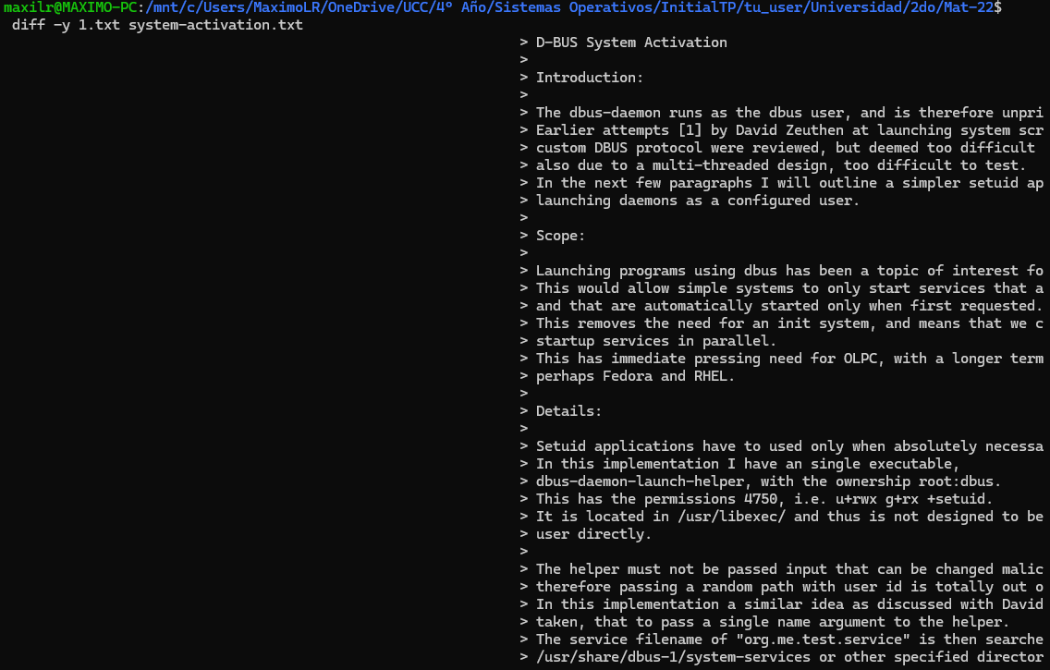

**Nota: “1.txt” está vacío**

**7.**

| **mv system-activation.txt ../../3er/Mat-31** |
| --- |



**8.**

| **file ../../3er/Mat-31/system-activation.txt** |
| --- |



**9.**

| **tree -d** |
| --- |

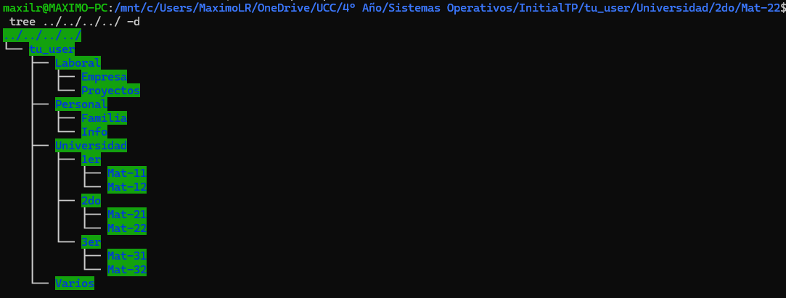

**10.**

| **zip -r Universidad.zip Universidad/** |
| --- |

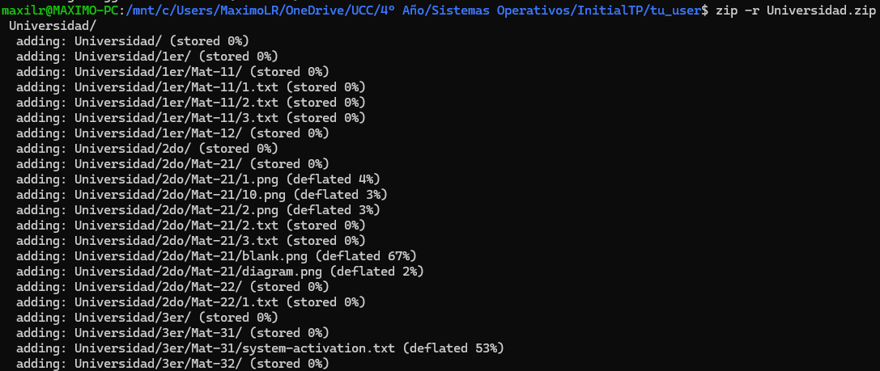

**11.**

| **mv Universidad.zip Personal/** |
| --- |

